First Article:
- Title - “Estimating an individual’s oxygen uptake during cycling exercise with a recurrent neural network trained from easy-to-obtain inputs: a pilot study”
- Article – Click Here
- Kaggle Data – Click Here
- Research Question – Can recurrent neural networks, Long-Short Term Memory (LSTM) outperform traditional predictive models (kinetics equations) by using easy-to-obtain inputs?
- Participants – 7 Amateur Cyclists (Completed both protocols)
- Method:
  - X Variables: VO₂, Respiratory frequency, Mechanical power, Pedaling cadence
  - Timeframe: 70 Breaths
    - Was selected, because that what worked best
  - Y Variable: VO₂
  - Definitions:
    - P1 – Light
    - P2 – Moderate
    - P3 – Intense
  - First protocol:
    - Warm-up (10 min)
    - Repeated three times – P2 (4 min), P3 (4 min), P1(4 min)
  - Second protocol:
    - Warm-up (10 min)
    - P1 to P3 over 4 min (ramping phase)
    - P3 (1 min)
    - P1 (4 min)
    - P1 to P2 over 1 min (ramping phase)
    - P2 (3 min)
    - P1 (4 min)
    - P1 to P2 over 2 min (ramping phase)
    - P2 (2 min)
    - P1 (4 min)
  - Wingate Test- Click Here
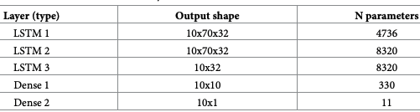
- LSTM Model:
10 batch size
20 epochs
GPUs used
Adagrad
Tensorflow
Python
- Results:
  - LSTM
    - First Protocol – 0.89 R²
    - Second Protocol – 0.8 R²
  - If you want to see the traditional models look at the appendix section of the paper.

Second Article:
- Title - “Predicting oxygen uptake responses during cycling at varied intensities using an artificial neural network”
- Article – Click Here
- No Data :(
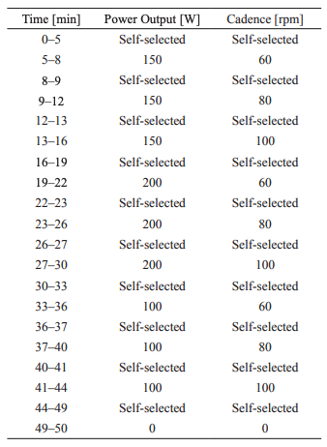
- Research Question – pretty much the same as the last paper just no traditional models
- Participants – 12 Healthy Males
- Method:
  - X Variables - power, cadence, HR, time derivative of HR, and body mass
  - Protocol (figure)
- RNN Model (figure)
Matlab
Fitnet (some weird model offered in Matlab)
Leave one-out method
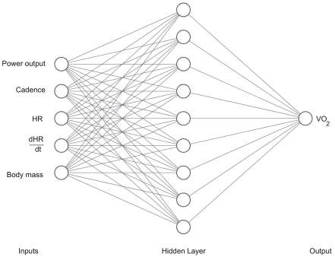
- Results: 0.91 R²

Thoughts:
I think the X variables of the second study are easier to collect, but I think using a similar approach for building the neural network in the first study is better.

